Grazioso Salvare Rescue Dog Dashboard
CS 340: Client/Server Development
Southern New Hampshire University
Author: Alex Simonian

Project Overview
This project is an interactive dashboard created for Grazioso Salvare. The purpose of the dashboard is to help identify dogs from the Austin Animal Center dataset that may be good candidates for search-and-rescue training.
The dashboard connects to a MongoDB database and allows the user to filter the animal data based on different types of rescue work.
The dashboard includes:
- Water Rescue
- Mountain or Wilderness Rescue
- Disaster or Individual Tracking
- Reset to show all animals
- An interactive data table
- A pie chart showing the breeds in the current results
- A map showing the location of the selected animal
- The Grazioso Salvare logo
- A unique creator identifier
The data table also allows the user to sort columns, filter individual columns, move between pages, and select an animal.

Dashboard Functionality
When the dashboard first opens, it displays the full animal dataset without any filters.
The filter buttons allow the user to select a specific type of rescue dog.

Water Rescue
The Water Rescue filter looks for:
- Labrador Retriever Mix
- Chesapeake Bay Retriever
- Newfoundland
- Intact Female
- Between 26 and 156 weeks old

Mountain or Wilderness Rescue
The Mountain or Wilderness Rescue filter looks for:
- German Shepherd
- Alaskan Malamute
- Old English Sheepdog
- Siberian Husky
- Rottweiler
- Intact Male
- Between 26 and 156 weeks old

Disaster or Individual Tracking
The Disaster or Individual Tracking filter looks for:
- Doberman Pinscher
- German Shepherd
- Golden Retriever
- Bloodhound
- Rottweiler
- Intact Male
- Between 20 and 300 weeks old

Reset
The Reset option removes the filters and returns the dashboard to the original full dataset.
The table, pie chart, and map update when the selected filter changes.

Tools Used

Python
Python was used to build the dashboard and connect the different parts of the project together. It was also used to work with the data returned from MongoDB.

MongoDB
MongoDB was used to store the animal shelter data.
MongoDB works well for this project because the animal records can be stored as documents containing fields such as breed, sex, age, name, and location.
The project also uses the Python MongoDB tools from the previous project to perform CRUD operations. CRUD stands for:
- Create
- Read
- Update
- Delete
For this dashboard, the main operation being used is Read, since the dashboard needs to retrieve animal records from the database.
MongoDB also works well with Python because the database records can be returned as Python dictionaries. This makes it easier to work with the data in pandas and display it in the dashboard.

Dash
Dash was used to create the web dashboard.
Instead of creating separate HTML and JavaScript files, the dashboard can be built directly in Python. Dash provides components such as buttons, tables, graphs, and other interactive controls.
The dashboard uses Dash callbacks to connect the different components. For example, when a user selects the Water Rescue filter, the callback runs the correct database query and updates the table. The chart and map can then use the updated table data.

Pandas
Pandas was used to work with the data after it was retrieved from MongoDB.
The MongoDB results are converted into a pandas DataFrame. This makes it easier to work with the data and create the pie chart.

Plotly
Plotly was used to create the pie chart showing the different dog breeds in the current results.
The chart changes when the user selects a different filter.

Dash Leaflet
Dash Leaflet was used to create the map.
When the user selects an animal from the table, the map displays a marker using that animal’s latitude and longitude.

How the Project Was Built
The project was completed in several steps.
- I connected the dashboard to the MongoDB database using the AnimalShelter CRUD Python module from Project One.
- I retrieved the complete animal dataset and displayed it in the dashboard’s data table.
- I added features to the table including sorting, filtering, pagination, and selecting a single row.
- I created MongoDB queries for each of the three rescue types.
- I added radio buttons so the user can select which rescue type they want to search for.
- I created a callback that runs the correct MongoDB query when a filter is selected.
- I connected the filtered data to the dashboard table.
- I created a pie chart that displays the breed information from the current table data.
- I added the map that displays the location of the selected animal.
- I added the Grazioso Salvare logo and my creator identifier to the dashboard.
- I tested each filter to make sure the table, chart, and map responded correctly.

Challenges
One challenge I ran into was an indentation error in the filter callback.
The if, elif, and else sections were not lined up correctly. Python requires these sections to use consistent indentation. I fixed the problem by reorganizing the code and making sure each section used the same indentation.
Another problem was a leftover closing parenthesis from the starter code. After adding the DataTable code, the original closing parenthesis was no longer needed. This caused a syntax error. I found the extra parenthesis and removed it.
I also ran into a NoneType error when the dashboard first loaded.
The problem happened because the cell-highlighting callback expected selected_columns to contain a value. When the dashboard first opened, there were no selected columns, so the value was None.
I fixed this by checking whether selected_columns was None before trying to use it. If it is None, the callback simply returns an empty list.

Testing
I tested the dashboard by running each of the required filter options:
- Starting state with the full dataset
- Water Rescue
- Mountain or Wilderness Rescue
- Disaster or Individual Tracking
- Reset
The screenshots below show the dashboard working in each of these states.

Starting State
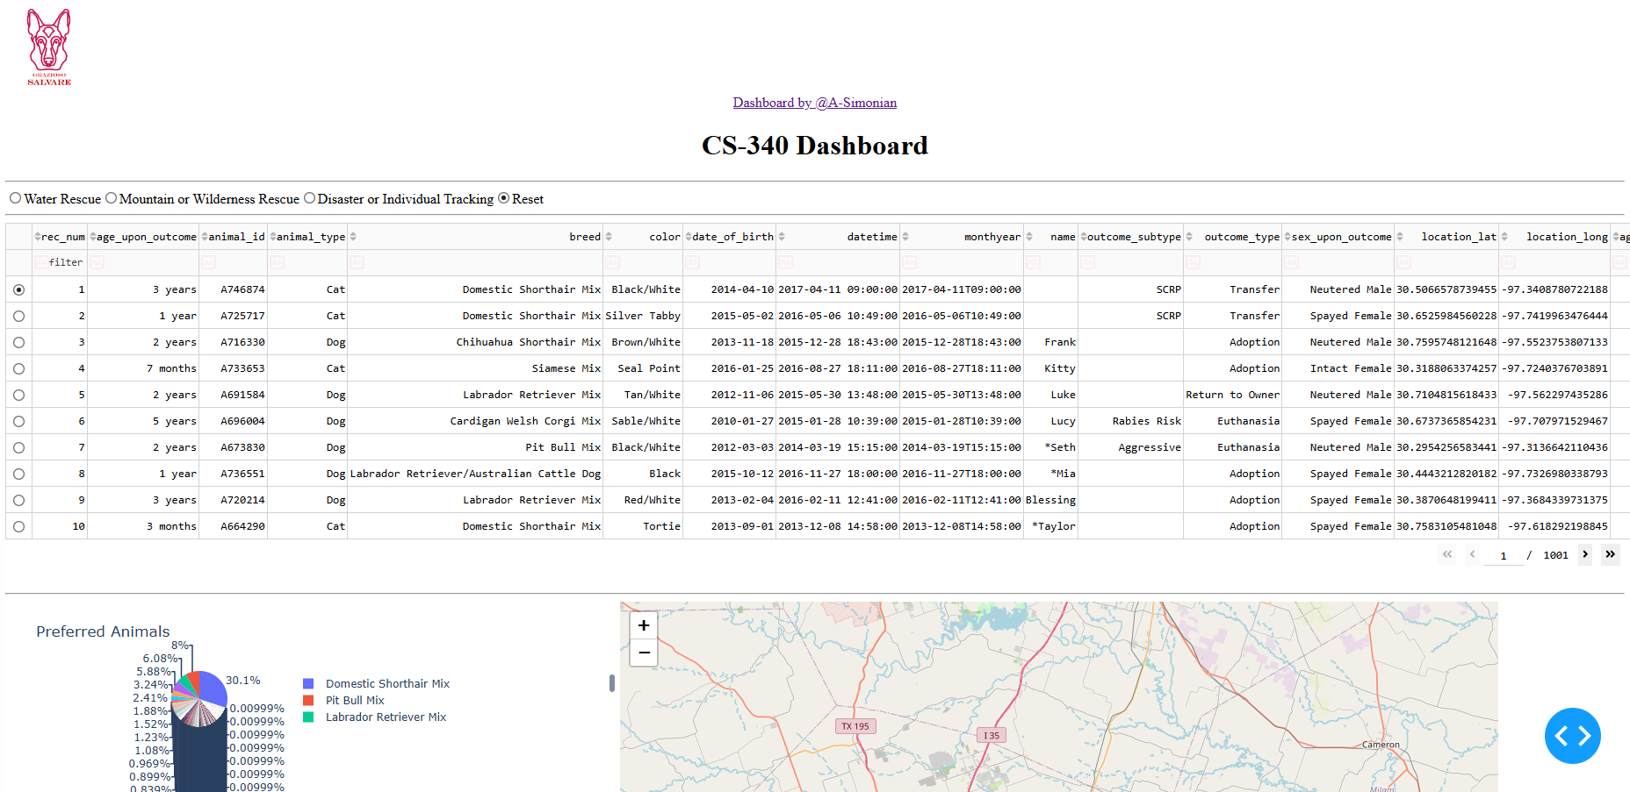

Water Rescue
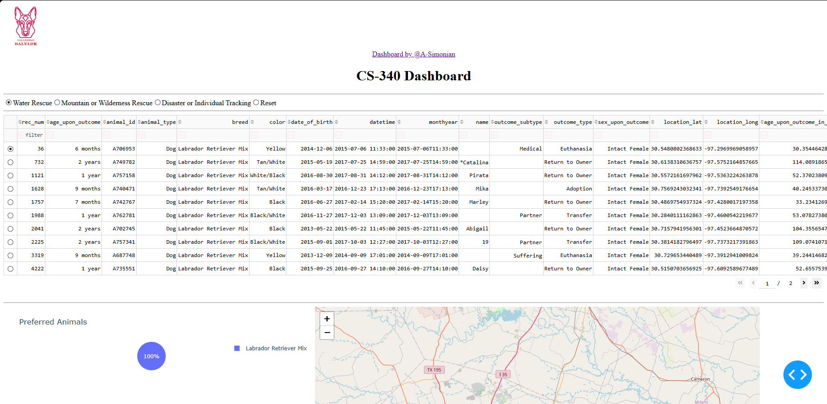

Mountain or Wilderness Rescue
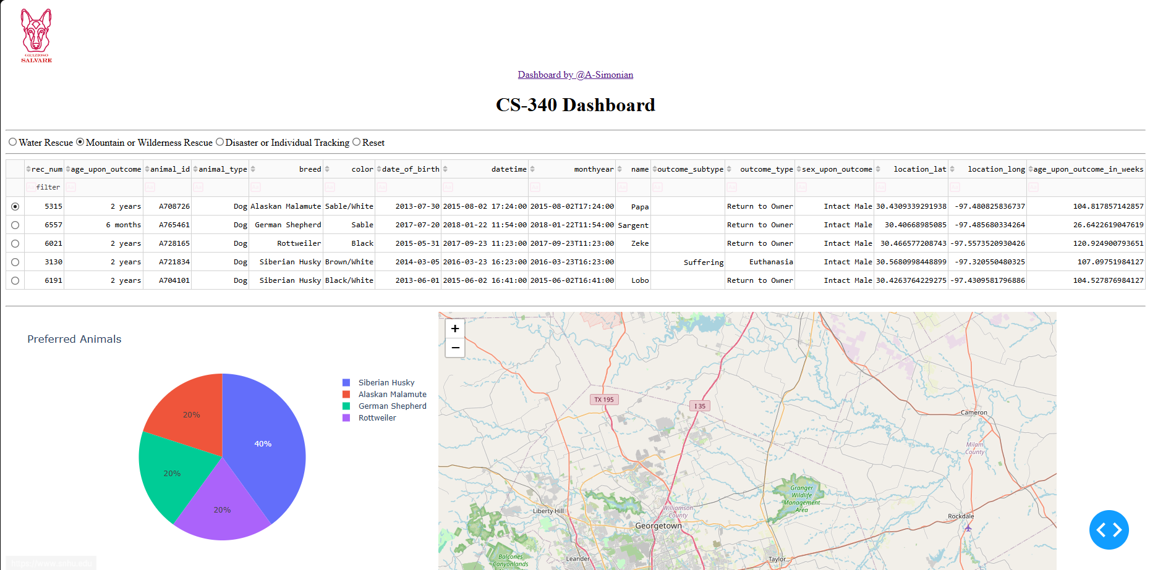

Disaster or Individual Tracking
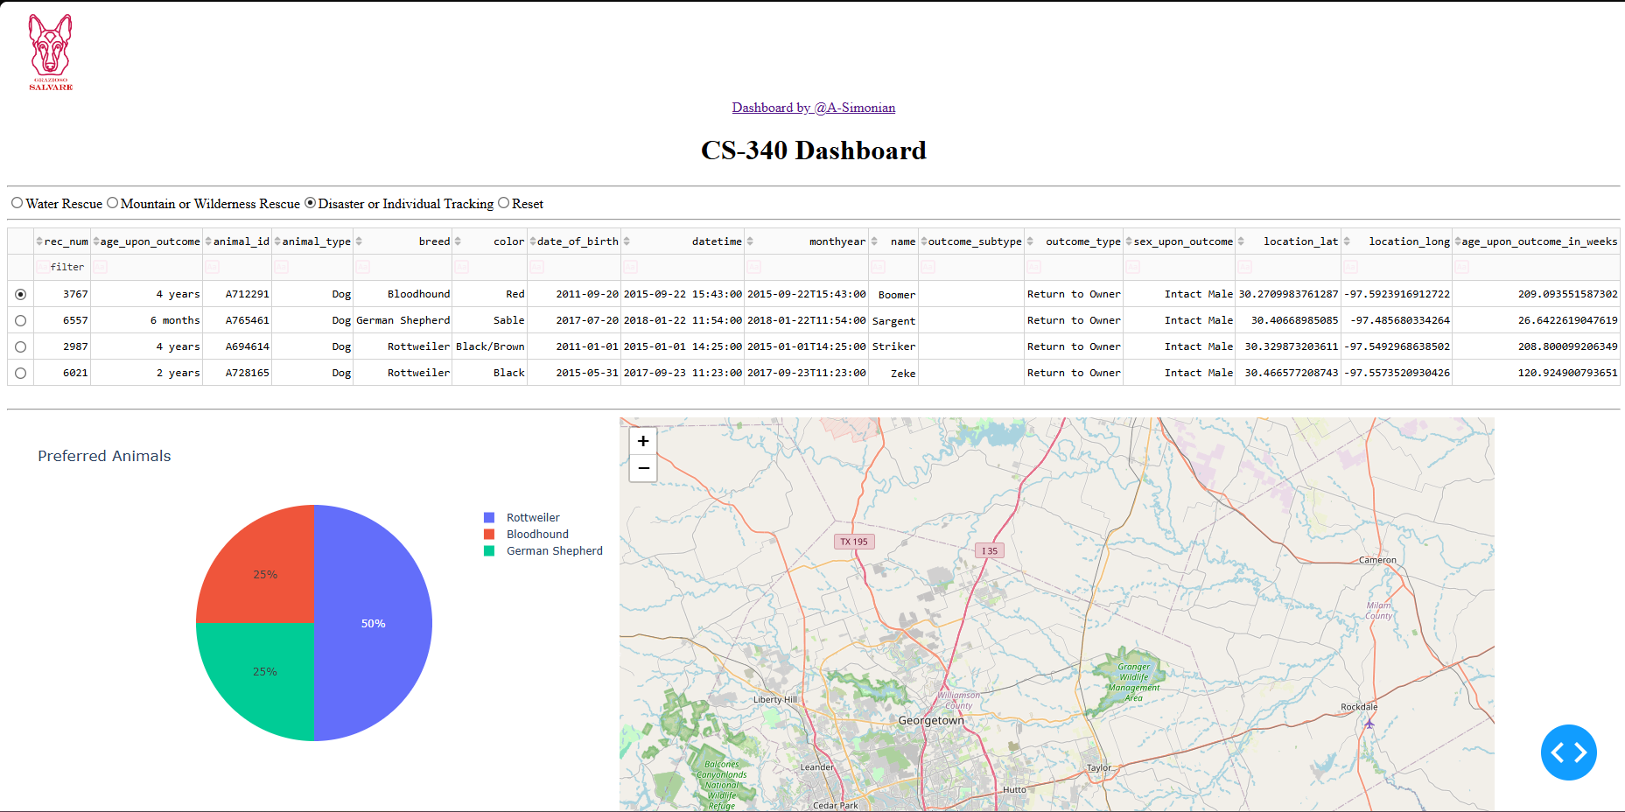

Reset
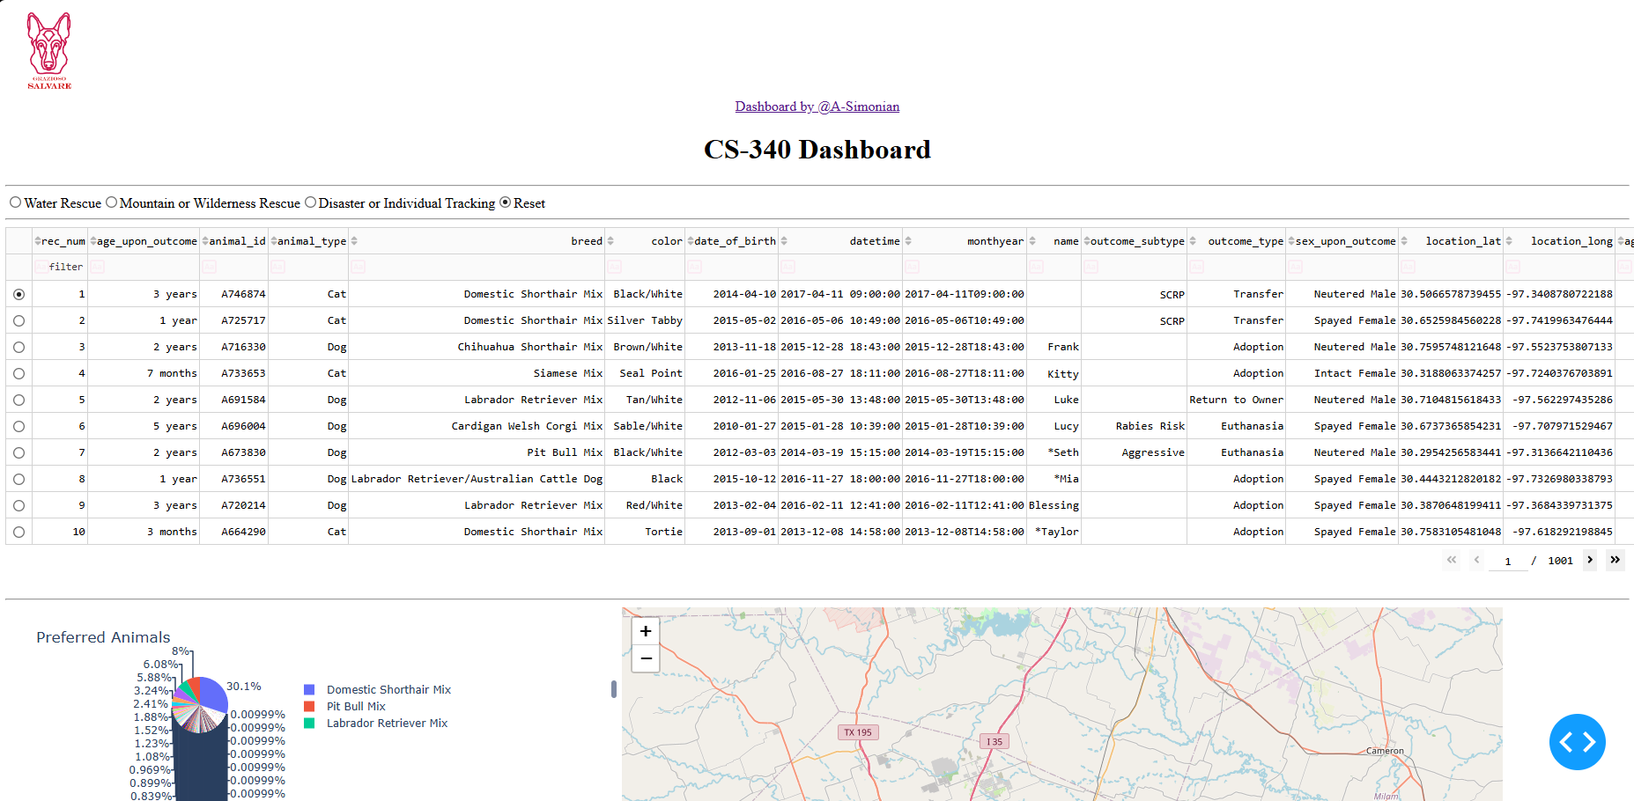

Resources
The following resources were used while completing the project:
- Dash documentation
- Dash Core Components documentation
- MongoDB documentation
- PyMongo documentation
- Plotly documentation
- Dash Leaflet documentation
- Austin Animal Center Outcomes dataset
- Southern New Hampshire University course materials

Conclusion
This project combined MongoDB, Python, pandas, and Dash to create an interactive dashboard for Grazioso Salvare.
The finished dashboard allows users to quickly filter the shelter data and view possible rescue dogs. The table, chart, and map update based on the information selected by the user.
This project also provided experience connecting a database to a Python application and using that data to create an interactive client-facing dashboard.

